ROADMAP – FRONT END

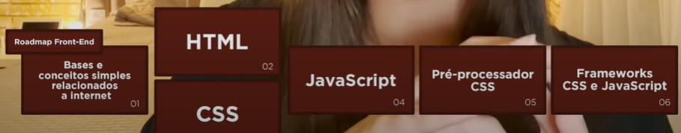

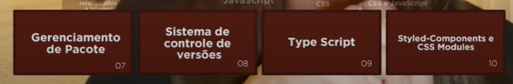

ROADMAP – BACK END

